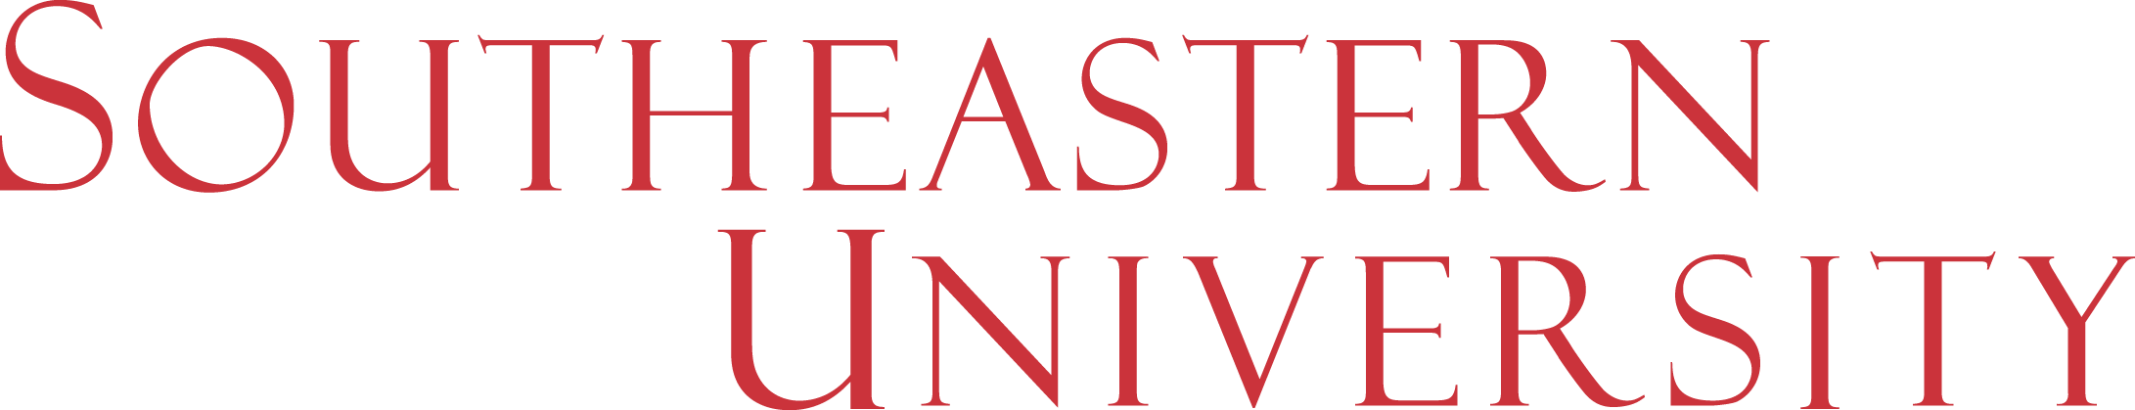

Academic Programs Committee (APC) Executive Summary
Date: November 28, 2017
Core Review Team: Andrew Permenter, Mark Biddinger, Cody Lloyd, Ken Reaves, Brandt Merritt
Master of Science in Kinesiology

External Market/Job Demand
Seismic shifts are forcing a morphing of Kinesiology programs from their historic STEM focus to more of an education/sports administration program. SEU’s new MS program is focused at this later growing segment. This program offers a number of viable career paths where an MS degree would prove beneficial. The market appears to be strong. 25/30
Internal Market
There appears to be good evidence of a strong demand within our current UG Kinesiology majors based on several student surveys within the department. The rapid growth of the UG program (over 250 students this fall) since its launch just three years ago indicates that there is a strong market in this discipline. 20/20
Financial Pro Forma
If the program is delivered in hybrid format (rather than purely online), the financial metrics are strong, more than breaking even the first year, and generating a 54% contribution margin by the fifth year of nearly $1,000,000 cumulatively. 30/30
Mission/Master Plan
The program aligns very nicely with our mission as well as the master plan relative to very healthy, sustainable numerical and percentage growth. Anything related to health sciences tends to be strong and this is an area where we can make inroads. 19/20

Total Score – 94/100
Recommendation – SEU should launch this program in Fall 2018 in hybrid format (campus based weekly classes or intensives supplemented by online work). Current UG Kinesiology students could do this program as a 4 +1. New students coming from other programs can do it as a stand-alone program. The concentration in Sports Administration can be marketed as leading to a wide variety of fields including physical education, coaching, kinesiology, and sports management.

